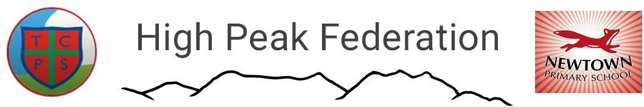

Executive Head Teacher – Mr Ashley Parry

Thornsett Primary School Newtown Primary School
Aspenshaw Road Buxton Road
Birch Vale New Mills
High Peak High Peak
SK22 1AT SK22 3JS
01663 744391 01663 744358
info@thornsett.derbyshire.sch.uk info@newtown.derbyshire.sch.uk
www.thornsett.derbyshire.sch.uk www.newtownprimary.co.uk

17th July 2020

Dear Parents,

As your child will no longer be entitled to Universal Infant Free School Meals from September 2020 we have to ask you to pay for their lunch at a cost of £2.20 per day.

You can pay for school dinners termly, monthly or weekly. Currently we are kindly asking you to use the School Money payment system to pay for school dinners. This allows you to put any amount onto your child’s account at a frequency to suit you.

All we ask is that their account remains in credit, so meals to need to be paid for IN ADVANCE. The amount due for this term until Thursday 22nd October 2020 is £79.20. This amount assumes lunches will be taken every day during the first half term (36 days at £2.20 per day).

We will send out a School Money welcome message containing your username and password to enable you to log on.

Thank you.

